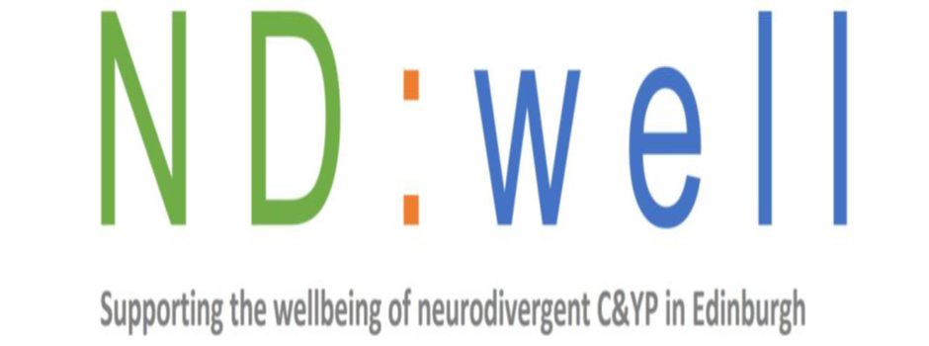

Drop – In Support 2025
Craigmillar Library
10am -1pm Monthly on a Tuesday dates below:
19th of August, 23rd of September, 21st of October, 18th of November, 16th of December.
Who is it for?
Our ND well service is for Parents who have a neurodivergent child 5-24years old who live in the City of Edinburgh. This includes children and young people with a diagnosis of autism, ADHD, and intellectual disability.
What can we help with?
We can provide a sounding board and listening ear from a skilled and experienced support worker. We can provide access to information, resources and guidance as needed. We can also refer you to our own services where suitable as well as our partners or signpost you to other services across the city that will best fit your needs.
How does it work?
Simply get in touch by emailing NDwell@barnardos.org.uk and booking a slot at a Drop-in.

