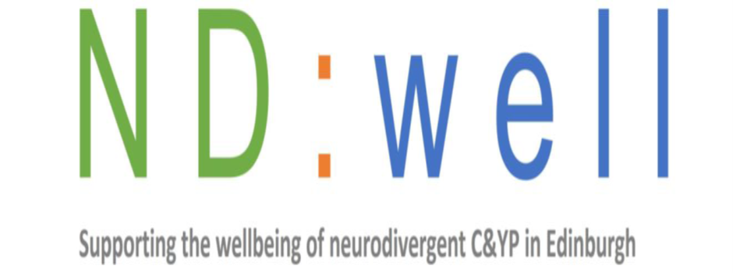
Barnardos Siblings group
111 Oxgangs Road North Edinburgh EH14 1ED
Monthly on a Saturday morning 10am -11.30am
Who is it for?
Children and young people aged 7- 12 years old who have a sibling who is neurodivergent.
What do we do?
We provide a safe and fun environment that children can learn more about neurodivergence as well as meeting others like themselves. We make sure to have lots of games and fun as well as an amazing snack!
How does it work?
Simply get in touch by emailing NDwell@barnardos.org.uk
let us know your child is interested in coming along. (We will let you know the dates when you email.)


