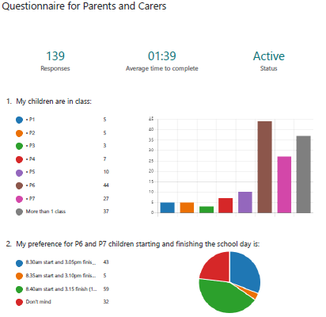

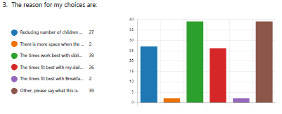
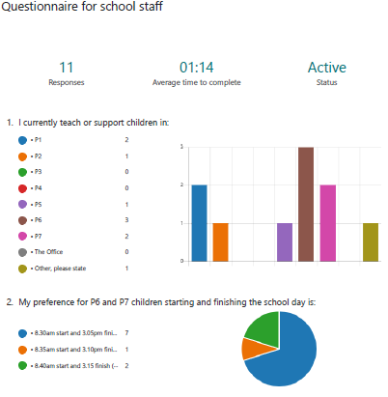
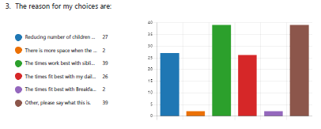

Questionnaire for pupils

Responses
My preference for P6 and P7 children starting and finishing the school day is:

 | 8.30am start and 3.05pm finish | 8.35am start and 3.10pm finish | 8.40am start and 3.15pm finish | No opinion
P3A | 30
P3B | 5 | 10 | 15
P3C | 7 | 8 | 15
P3/4 | 24
P4A | 32
P4B | 2 | 9 | 13
P5A | 15 | 7 | 5
P5B | 10 | 0 | 0 | 8
P5C | 13 | 6 | 4
P6A | 15 | 5 | 7
P6B | 22 | 5 | 2
P6C | 21 | 4 | 1
P7A | 26 | 2 | 2
P7B | 2 | 6 | 19
P7C | 20 | 5 | 3
TOTAL | 244 | 67 | 86 | 8

The reason for my choices are:
 | Reducing number of children arriving in school at the same time | There is more space when we line up in the playground and go through the doors | The times work best with my brothers and/or sisters in school | The times fit best with my daily routine. | The times fit best with Breakfast, Kidzcare, or other care club I go to | Other, please say what this is.
P3A |  | 30
P3B
P3C | 12 | 2 | 6 | 5 | 3
P3/4 | 24 | 24 |  |  |  | P6/7 more responsible, work in mornings
P4A | 32 | 32
P4B
P5A
P5B | 18
P5C | 3 | 13 | 2 | 2 | 2 | 4 – More time in the morning
P6A |  |  | 1 | 27
P6B |  | 3 | 2 | 22 |  | 2 – Can enjoy playground and talking to people  I get up really early so would be in school early anyway
P6C | 1 | 1 | 3 | 18 | 2 | 1 – I don’t want things to change again  1 – I often sleep in  All the children like the idea of outdoor clocks in the playground, one for each area. And please continue with no bells.
P7A | 1 |  | 17 | 6 |  | Suits with walking to school  Rest like to finish at 3.05, gives them time to go home and get a snack and changed for clubs and activities.
P7B |  |  |  |  |  | Some children may have arranged clubs according to current finishing time
P7C |  |  | 5 | 24 | 2 | 1 – I am often late to school
TOTAL | 91 | 105 | 36 | 104 | 9

