TENNIS THIS EASTER - FROM TOTS TO TENNIS LEADERS

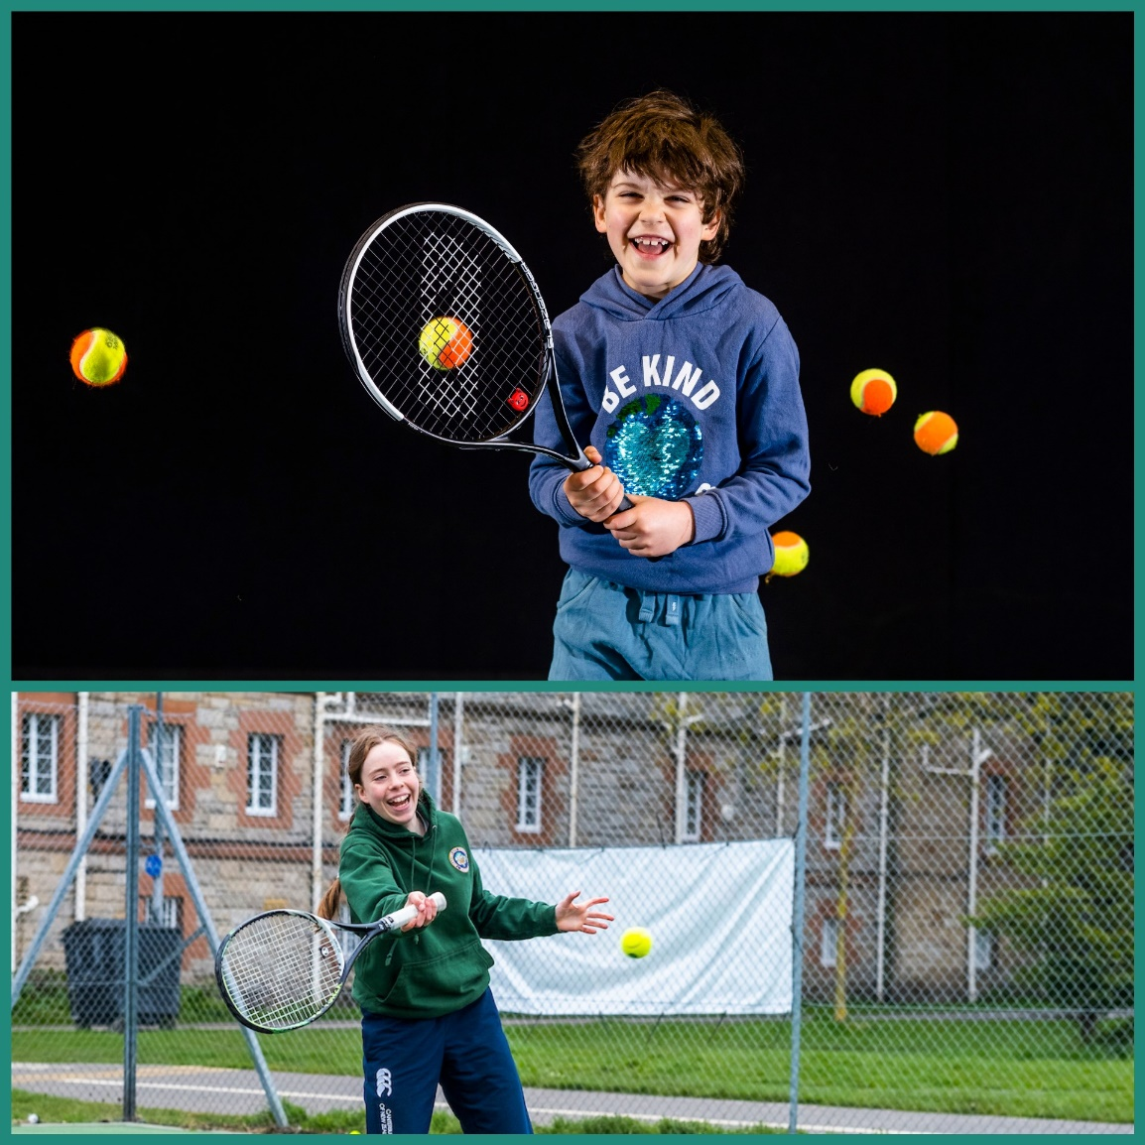

We have something for everyone these Easter Holidays at Craiglockhart Tennis Centre and at the Meadows – for full details and to book please go to -
https://ecom.roller.app/craiglockhartleisureandtenniscentre/holidaytennis/en/home



