Office 365 – Pupil Login instructions – Internet and App Access
1. Instructions for accessing Microsoft Teams via the internet
Go to https://digitallearningteam.org/
Select Learners - Office 365 Login
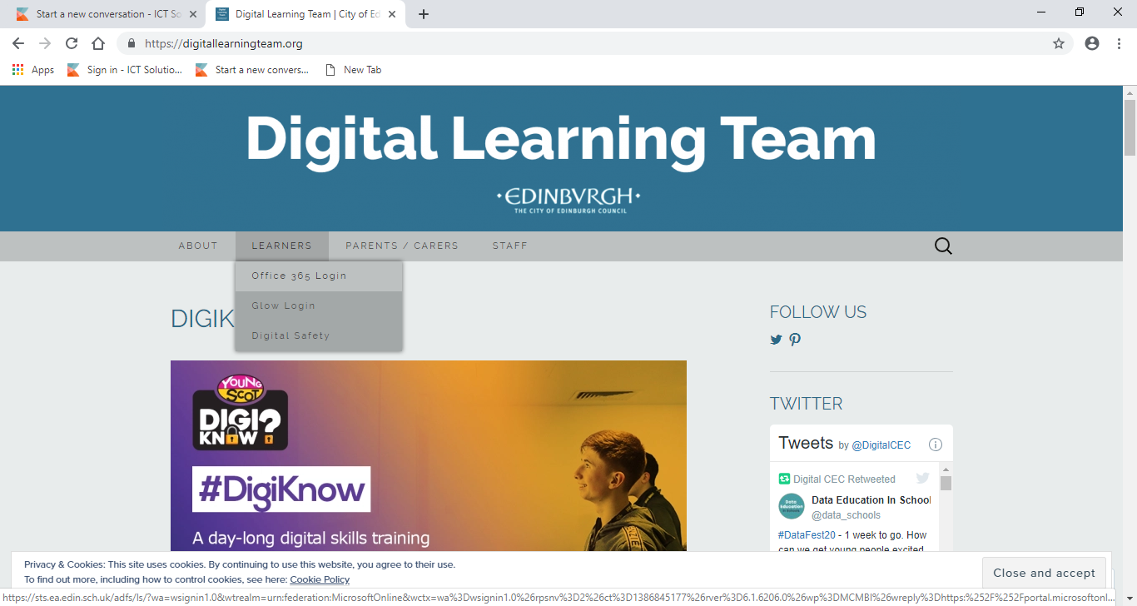
The following screen will pop up.
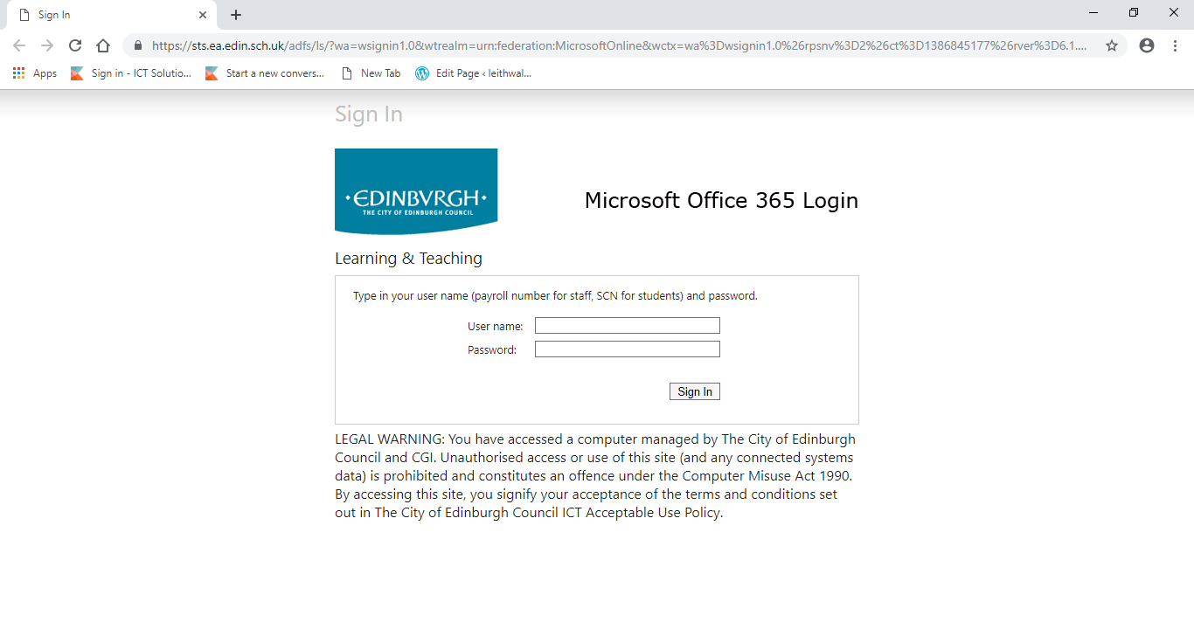
In the username field, enter the unique student code which is the 9-digit number on your password information slip (your email address is this number followed by @ea.edin.sch.uk or as is printed on the slip).
In the password field, enter the code provided on your password information slip – this is a combination of letters (lower and upper case) and numbers.
Click sign in – you should see the following page (a welcome pop-up may appear on first login)
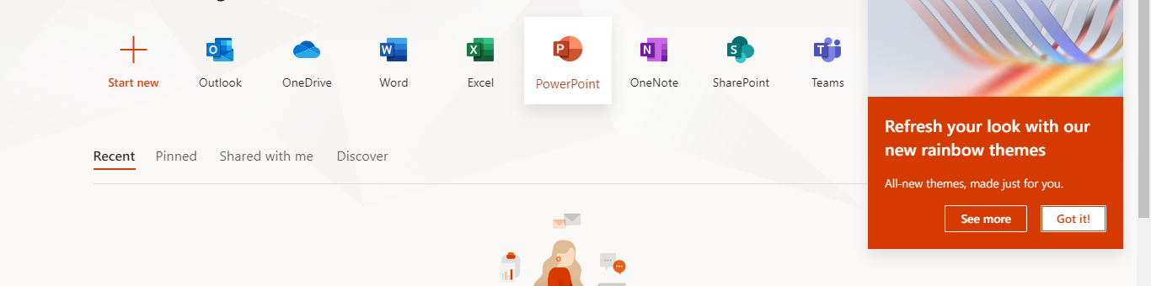
Email and Teams will be used to communicate with pupils in class groups. If you experience any difficulties logging in please contact the school for support.
2. Instructions for accessing Microsoft Teams via the app
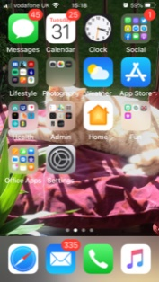 | Select your App Store (or Google Play for Android) icon on your smartphone or tablet.
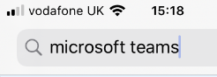 | Search for Microsoft teams.
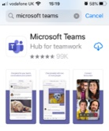 | Click to download the Microsoft Teams App.
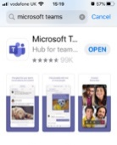 | Open the downloaded Microsoft Teams App.
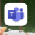 | Find the Microsoft Teams icon on your smart phone and click on it.
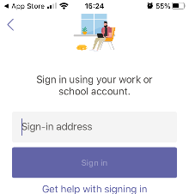 | You will be prompted to enter your sign in address.
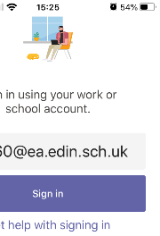 | This is your 9 digit number followed by @ea.edin.sch.uk  E.G. 123456789@ea.edin.sch.uk
 | If this is the first time you use Teams, you may see the Learning and Teaching sign-in screen. Enter your 9 digit number in username and your unique password.
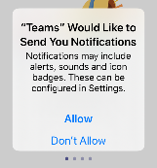 | We suggest you click ‘don’t allow’ notifications.
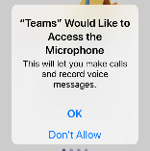 | We suggest you click ‘don’t allow’ for microphone access.
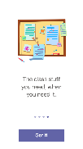 | If this is your first time you use Teams, you will see some welcome notices. After that you will see the Team that you have access to.
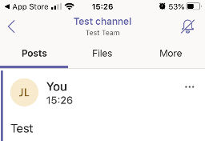 | Click on the tile for your class team and join in!

If you experience any difficulties logging in, please contact the school for support.

