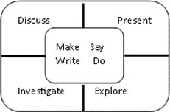
Learning at Home during School Closures for P7
Week beginning: 22/02/21
Week 6
Hello P7 & families,

Welcome to Week 6
This week we are continuing our work on air raids and The Blitz and thinking about how it would feel to be in that situation. We hope you are enjoying creating your models and dioramas and are looking forward to seeing all your models. Look forward to seeing you at our daily check-ins where we will continue to discuss any issues, answer questions and most importantly chat to you about how you are getting on with your learning.

Hope you all have a great week!

The P7 Teachers

DAILY ACTIVITIES (New activities every week)
Literacy and English: Spelling  This week, we are focusing on words with si, ci and ti. In the spelling folder you will find the sheet containing the word lists (which are also below), the worksheets for each of the lists and a voice recording of each list so you can test yourself. Remember, you can work between two lists, if you prefer.  1) musician 2) amnesia 3) exercised 4) incidental 5) medicinal 6) pronunciation 7) specialism  8) mathematician 9) penicillin 10) councillor  11) precipitation 12) conclusion 13) nationality 14) infectiously 15) graciously 16) impartial 17) financially 18) impatiently 19) divisible 20) ancient 21) assassin 22) cursive 23) basically 24) tonsilitis 25) casino 26) velocity  27) conversion 28) indecision 29) circumference 30) inconclusive 31) citizenship 32) partially 33) tenacious 34) illusionary 35) adhesive  1) gracious 2) partial 3) conclusion 4) mansion 5) musician 6) suspicion 7) division 8) financial 9) invasion 10) ancient 11) infection 12) abrasive 13) tension 14) elusive 15) impulsive 16) decision 17) cursive 18) confusion 19) intrusion 20) illusion 21) initial 22) martial 23) solution 24) Egyptian 25) politician 26) velocity 27) physician 28) fusion 29) profession 30) occasion 31) technician 32) beautician 33) electrician 34) decimals 35) noisiest  1) easier 2) vision 3) television 4) nation 5) patient 6) sign 7) size 8) circle 9) cider 10) circus 11) pencil 12) decimal 13) mission 14) decide 15) action 16) station 17) basic 18) cinema 19) city 20) acid 21) icing 22) lotion 23) section 24) pension 25) recite  Tasks for spelling this week.  Activities  Monday  Do a pre-test yourself from the recordings. They are all on a PowerPoint.  Tuesday  Wednesday  Spelling grid – Choose an activity from the spelling grid or make up your own activity.  Thursday  Complete the worksheet for your list.  LI – to show I can use the words in context/ understand the meanings as well as spell the words accurately.  Friday  Check-up – use the voice recordings of the words to test yourself at the end of the week. How many did you get correct? Any corrections, practise again a few times. | Literacy and English  Personal reading daily  Choose a book you enjoy reading at home, try to continue with the good habits we have formed at school by reading for at least 30 mins a day. It would be great if, during our ‘check in’ sessions each day you could share what you are reading personally. It’s always good to get recommendations from your friends and good for your teachers to find out which types of books you are most interested in. Remember this Thinglink virtual library which has links to audio books, read yourself books and author live sessions.  https://www.thinglink.com/card/1406688310872506371?fbclid=IwAR0P80bwx7rtIGbniNhAYF54j5ouLysZcwZ3jpmWKFko494uf1faKSJoA  Reading Comprehension  ASSIGNMENT TASK  Hot activity – Part 2 of Golden Skies  Spicy activity – The Blitz  Read the passages and answer the accompanying questions.  Writing  ASSIGNMENT TASK  ***DO THE SOCIAL STUDIES MIND MAP BEFORE THIS TASK AND USE IT TO SUPPORT YOUR WRITING.***  Learning Intention: To write an imaginative story about a child’s experience of being in WW2.  Success Criteria: I can…  - Write in the first or third person  - To continue on in the style of the story starter.  - Try to use ambitious vocabulary to describe the sights, sounds, fears and reactions.  Pick one of the story Starter provided in the writing folder, continue on using the style of the author. Using all the information you have learned over the project, think about how they might react and how they might feel. Remember for second level we are looking for at least a page and half and try and vary your sentence openers and connectives.  Listening & Talking  Class Novel  Story time with your teacher!! We will continue to read our class novels to you so grab a snack, get comfy and listen carefully. There will be an opportunity to discuss the novel – your teacher will let you know when.  Listening Comprehension  Watch and listen to this BBC video.  A Soldier’s Daughter  Sarah discusses her childhood experiences as she grew up during WWII with Tyler. Once you have listened to the clip answer the questions. | Maths and Numeracy  This week in maths you have a mission to complete. After Dunkirk, you are in charge of getting the survivors back to Britain safely. You have a selection of ships and boats and you need to work out which to use and how long it will take to get everyone back. As well as that you need to think about protecting the boats and ships. See the maths folder for further mission details and good luck!  ______________  ASSIGNMENT  You will also get your daily maths activities set by your teacher Tuesday through to Friday. Your teacher will tell you which day your assignment is due on.  Mental Maths Games  Continue to use Sumdog for Maths and Numeracy practice.  https://www.sumdog.com  We will continue to review your results for setting future challenges.  Problem Solving  Transum  https://www.transum.org/Software/SW/Starter_of_the_day/  Have a look at the ‘Starters of the Day’ for February and choose a problem a day to solve. They can be tricky so look through them all to find one at your level.  Optional Extra Problem Solving  The Daily Rigour  https://www.cdmasterworks.co.uk/the-daily-rigour/ | Health and Wellbeing  PE  Exercise Pyramid – See the task in the PE folder it will help you build up stamina as you add a new activity every day.  Joe Wicks will be doing workouts Monday/Wednesday and Friday so join in!  Just Dance – We know you love a just dance in P7 so have a go of 2 or dances a day.  Yoga – if you would like some more mindful exercise, try Adriene’s yoga.  https://www.youtube.com/watch?v=vMMRb10LtGM  https://www.youtube.com/watch?v=Td6zFtZPkJ4  Also there are free sessions from Active schools you can access.  Access Free Sport & Physical Activity sessions 4pm daily from Active Schools  At: Active Schools Edinburgh YouTube Channel  ______________  Heath & Wellbeing – Random Acts of Kindness.  We all need to look after each other just now. We missed The Random Acts of Kindness day on the 17th of February but have a look at the random acts of kindness bingo sheet in the PE file and see if you can brighten up somebody in your family or a friends day by doing one or more of the suggestions each day. Try to get a bingo of them!!

CHOICE ACTIVITIES
Social Studies  LI: I can investigate and I understand what The Blitz was and how it affected people in towns and cities in Britain.  Watch  https://www.bbc.co.uk/teach/class-clips-video/history-ks2-the-blitz/zm22jhv and fill in The Blitz mind map as you watch it.  WW2 Military Machines  During The Blitz people got used to the sight of warplanes in the skies. People became expert at recognising the different aeroplanes involved. Other machines such as tanks and ships played a big part in WW2.  Watch https://www.bbc.co.uk/teach/class-clips-video/history-ks2-the-machines-of-world-war-two/zv9kcqt  Activity 2  Either research a machine in the second world war and create a fact file of information. You could include type of machine, top speed, number made, fire power, who it was used by and what for. Draw a picture of it in your fact file and make sure you add its markings.  OR  Complete the sheet in the Social Studies folder on The Hurricane then create a fact file with a picture of The Hurricane. | Art, Design and Technology  ASSIGNMENT  OVER TWO WEEKS  LI – to design and build either  - A model of an Anderson shelter  OR  - A diorama of a ‘Home Front’ scene  You should show evidence from planning through to completion.  - Sketch your design, deciding upon measurements. A shoebox is a perfect size, if you choose to do a diorama. (your parents may not thank you for taking over the house with your model)  - Make a list of the materials you will need for your project.  - Build your model and take note of any design problems you came across and how you solved them.  Further information and examples are in the Week 5 Technologies folder.  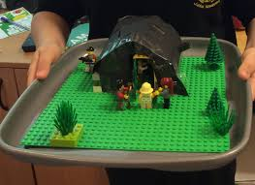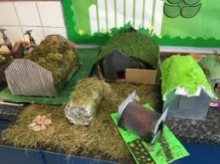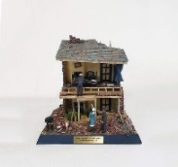  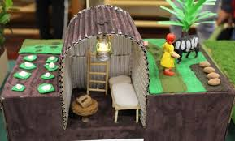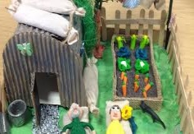  Art and Design  There is a choice of activities this week. However, if you like, you can try both.  Activity 1  As we head towards another World Book Day, at the beginning of March, we are going to take a look at the artwork of some illustrators and  author/ illustrators of younger children’s books. We could share some of our artwork with the younger year groups. This week we are going to look at the artwork of Mairi Hedderwick (of Katie Morag fame!) and hopefully be inspired by her techniques. There is a PowerPoint, entitled Mairi Hedderwick and some videos, demonstrating the techniques.  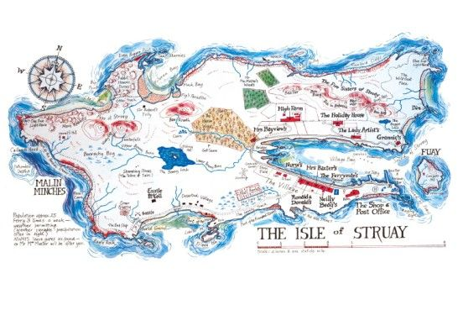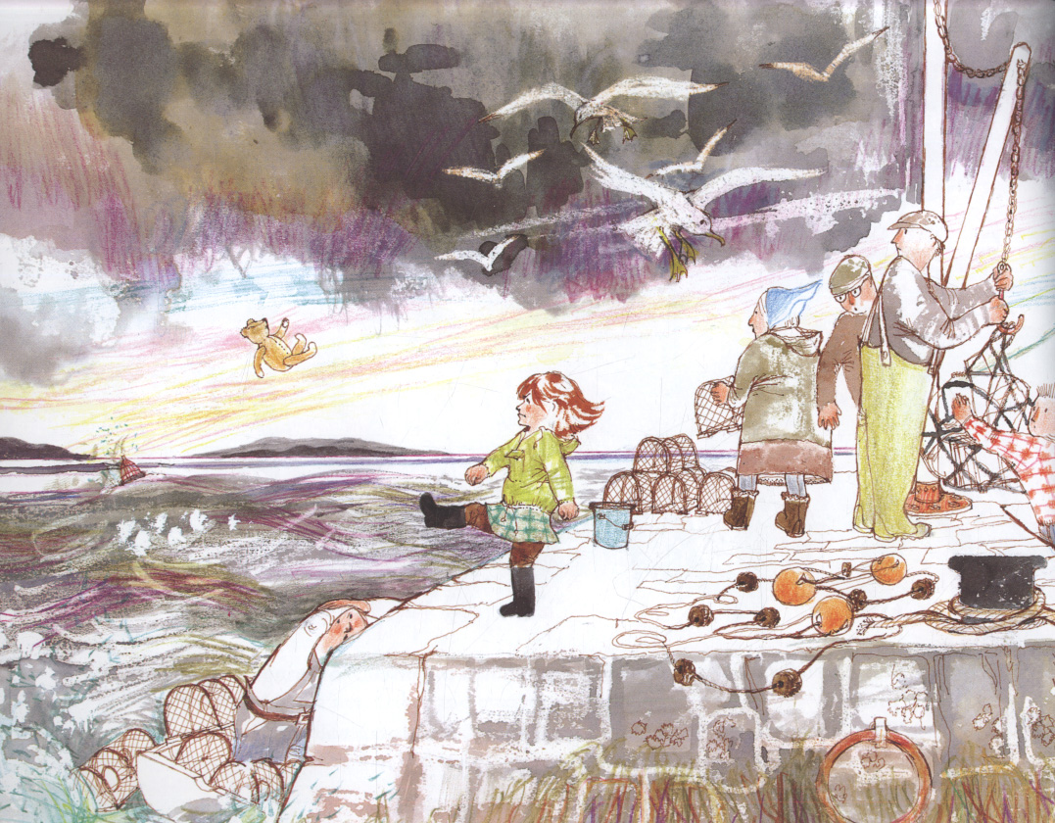  Activity 2  The Blitz – searchlight picture.  Using masking tape on paper, you can recreate a scene of the searchlights sweeping a city sky. The burning sky can be coloured with paint or pastels and the tape removed afterwards. Silhouetted buildings and planes can be added with shades of black and grey. Again, you can look at a PowerPoint and video to help you get started. | Modern Languages  French Clothes – Les vêtements  This week we are continuing to practise clothes vocabulary. Listen carefully to the clips to see if you can hear clothes mentioned.  Listening Activities  https://www.bbc.co.uk/teach/school-radio/french-ks2-radio-labo-8-les-vetements/zmbn2sg  Listen to Clip 29 on the school radio clip of 2 people talking about clothes at a fashion show. Listen carefully and play the memory game. They list 10 items of clothes. Listen pause and see how many you can write down. Can you remember what they are in English? If not go back to last weeks work and look them up. Pause and re listen if you need to.  Once you have done that listen to Clip 30 – a song about always wearing the same thing, what items of clothing are in the song? There is an animated version of the clip to help you near the end of the page.  Play  https://www.french-games.net/frenchlessons?topic=People%20-%20clothes%201&level=primary  Try a different game from last week.  German  Again, Charlotte will send us a pre-recorded lesson and we will post it on Teams when it arrives. Keep practising the vocabulary you have already learned.
Science (with Technologies, Art and Design and Social Studies)  Continued from last week  Keep Scotland Beautiful is running an exciting competition, which some of you might be interested in entering.  Whether you decide to go ahead and enter or not, we would like you to create a 2D design of the garden and choose and name the plants you would use. Read the deign brief carefully.  DESIGN A ONE PLANET PICNIC POCKET GARDEN.  opp-pocket-garden-comp-guide-2021-low-res-final101220.pdf (keepscotlandbeautiful.org)  “One Planet Picnic A One Planet Picnic is a picnic that is good for you and also good for the planet. That means using local and seasonal ingredients, organic and ethically sourced produce as well as reducing waste. There are lots of edible plants that grow very well in Scotland. Growing your own food is a great way to get local, seasonal produce. There are more edible plants than you find in the shops. Some flowers are edible too! What would you like to grow and eat?”  This ties in well with our WWII work and covers experiences and outcomes in TECHNOLOGIES, SOCIAL STUDIES, SCIENCE and ART AND DESIGN. As you know, with rationing, people were very much encouraged to grow their own food and many people grew plants on and around their Anderson Shelters to make good use of all the available space. Flowers too, cheered people up and encouraged wildlife into people’s gardens.  The idea is to design a small garden, measuring only 100cm x 120cm. It can be any shape you want but must fit into a rectangle of that size.  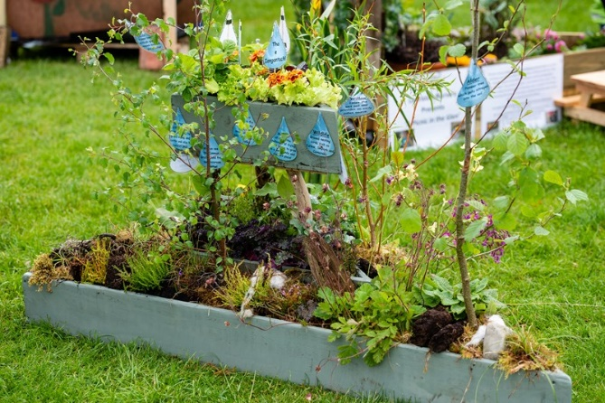 a previous winner |  | 🕵️  Drama  Spies and espionage were a big part of operations in WW2 and we will be finding out some information about them and their work next week.  This week we want you to consider the Role of a Spy! Think about - What is a spy? What are the stereotypical characteristics of a spy? How does a spy’s movement and voice differ from other character types? Your mission (if you choose to accept it) is to become a spy. You can choose to be a cartoon type spy, very obviously a spy or more of an undercover character. Can you find clothes or props round the house that would help you become a spy? Give yourself a super cool spy name and your first assignment is to do some observing. Spies need to be good at remembering small details. Get a notebook and make notes on what is happening around you. What are people doing/wearing? Make a note of the time this is happening. Note down small details. Later get someone to ask you questions on your notes, could you remember small details? Alternatively, you could put a selection of random objects on a tray. Observe for a minute, cover and then draw the tray with the objects. How accurate were you? Once tasks are completed you have passed Level 1 of Spy School.

