Sensory Poetry Reading Comprehension
Choose either the mild, hot or spicy task.
Read the poem very carefully (you may want to read the poem more than once) and answer the questions. Remember to write your answers in sentences where possible.

MILD TASK
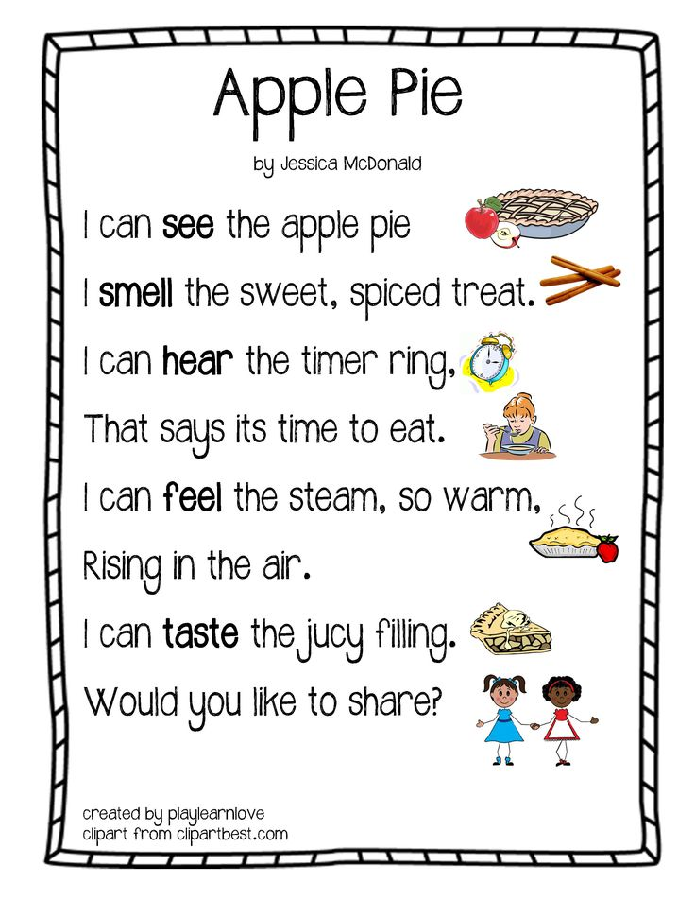
Questions:
- Can you sort the adjectives in the poem into the senses?
Sight | Smell | Touch | Sound | Taste

- Can you think of another word which means the same as ‘warm’?
- Can you think of a better title for this poem?
- Can you think of 3 adjectives to describe the taste of the apple pie (you cannot use ‘juicy’ as this is in the poem already)?

HOT TASK
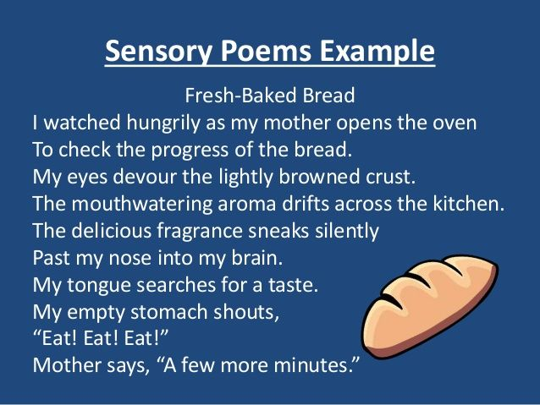
Questions:
- Can you sort the adjectives in the poem into the different senses’ categories?
Sight | Smell | Touch | Sound | Taste
- The poet describes the person in the poem ‘as watching hungrily’ – can you describe how you think the person looks after you read that? What would their facial expression be?
- Can you think of another 2 words which means the same as the word ‘abandon’?
- Can you think of a better title for this poem?
- Can you think of 3 adjectives to describe how the person is feeling at the end of this poem?

SPICY TASK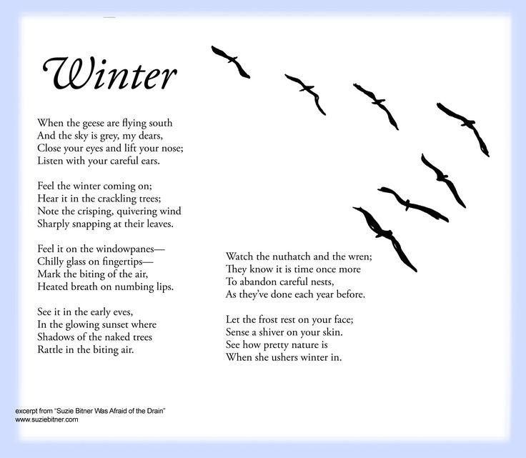

Questions:
- Can you sort the adjectives in the poem into the different senses’ categories?
Sight | Smell | Touch | Sound
- Can you think of a better title for this poem?
- Can you think of another 3 words which means the same as the word ‘abandon’?
- Can you think of another 3 words which means the same as the word ‘glowing’?
- Why are the ‘wrens’ abandoning the nests each year? Where are birds going?
- Why did the poet describe the trees as naked?

