We have included a Self-Reflection Grid at the end of this pack to help you think about your learning at the end of each day.

Literacy and English - Reading  Read a newspaper article, online or in print form. Who do you think the text you have chosen is aimed at? How do you know? What do you think is the purpose of this text? How do you know that? Summarise the key ideas in your own words. Identify any effective word choice, language, imagery or punctuation. Make a table of these examples and explain why you think they are good choices. Create 5 questions for someone else to answer. Make sure you write the answers too. | Health and Wellbeing – Increase Your Heart Rate  Before starting, remember to warm up your muscles with some stretches. Exercises to increase your heart rate don’t need to be about running or treadmills. Many games increase your heart rate without you realising it. Try this activity to help you move quickly and in different directions.  Place at least 6 objects in different areas around the room or garden. Place 6 markers in another area or in another room. Move one object at a time to the marker as fast as you can. Repeat until you have moved each of the objects to a different marker. How long did it take? Can you do it again but faster? Can you increase the number of objects?  Create a weekly activity plan. Try to aim for the recommended amount of 60 minutes of physical activity each day across the week. All activities should make you breathe faster and feel warmer. Choose activities you enjoy. | Expressive Arts (Drama) – Set Design  Imagine you are a becoming a Set Designer.  For additional help, you could watch the interviews with Set Designers videos from the National Theatre on YouTube. Select a Fairy Tale to design a production set for, e.g. Peter Pan, Hansel and Gretel, Beauty and the Beast, or any other favourite. Research on the web, or in a book at home for a summary of the story. Read this and make a list of all the locations in the story. Then select the elements of set design (flats, backdrops, rostra blocks, scenery etc) that you would use for each location in the story. Make notes on these. Draw or design a Set Design (drawing or diagram from the audience seats) for each scene – using the template provided.
Health and Wellbeing – Growing Confidence Trees  Our confidence grows over time, like a strong tree. This activity will help you explore some of the things you can do that will help your confidence grow stronger.  Find the activity later in this pack. You will need a piece of paper and some leaf shapes. | Numeracy and Mathematics – Adding and Subtracting Fractions  Can you add and subtract fractions and mixed numbers? Find the web later in the pack and find the answers to the calculations. | Science – Making Learning Stick  How do we make our learning stick? One way is to create questions based on what you have learned. Choose a topic that you have recently completed. Write 10 – 15 challenging quiz questions about what you have covered in the unit.  Write the questions and answers (on a separate sheet) to test a peer… Can you send it to someone in your class to see how well they know the work? You need to know the answers to your questions so you can check their responses.
Social Studies (Modern Studies) – News Time!  Watch a news bulletin (you could watch an episode of Newsround on CBBC or one of the adult bulletins e.g. Six O’clock News). Choose an item on the programme which relates to the government e.g. Covid, Brexit. Try to find out some different opinions on this news item e.g. what do the government think?, what does the opposition think? what do your family think? If you were Prime Minister what decisions would you make about this issue at the moment? | Literacy and English – Talking  Talk to a member of your family about the newspaper article you have read and the text you listened to. Tell them what you learned from the texts and what your opinion is of the topics raised in these. Ask them for their opinions on these topics. If they disagree with you, try to persuade them that your opinion is correct, using evidence you have gathered from your reading and listening. | Technologies (Computing) – Word Processing  Thinking of the Fetch Execute Cycle and your knowledge of computer architecture create a diagram that shows exactly what happens when you open a new word processing document, type some text and then save that word processing document. You should name all the parts of the processor that are involved at each stage. This should help you better understand how the computer works and just how efficient it can be.
Numeracy and Mathematics – Managing Time  How do you manage your time inside and outside of school? Use the activity later in the pack to help you plan and organise your time well. | Health and Wellbeing – Being Kind and Safe Online  There are many positive things about living in an increasingly digital world. Write a list of positive examples of the use of digital technology. Ask other people (maybe in your family) about how they use digital technology in their lives, and the positive difference it makes, e.g. booking a holiday. There can be downsides to digital technology too. Write a list of negative things that might arise using digital technology. What can you do about online content you come across which is inappropriate, upsetting or illegal? Think about some aspects of using digital technology that present risks or concern you. Find out more about how to deal with these issues by looking for advice online at https://www.thinkuknow.co.uk/. | Technologies – Food and Consumer Technology  Help to cook a meal at home. Take a photo of the finished dish and write down the recipe and steps you followed to make it. What did you think of your meal? Would you change anything if you made it again?
Media Studies – Video  Keep a video diary. You might include things like what you’ve been doing, how you are staying connected to people, how you are feeling and ways you are keeping yourself happy and safe. | Numeracy and Mathematics – Patterns and Relationships  Can you continue a pattern and then work out the rule? Look for the activity on patterns and relationships later in this pack to help you explore mathematical patterns and patterns in nature. | Literacy and English – Writing  Later in the pack we have activity where you can write a story about change. Read the initial paragraph to inspire you and continue the story.

Health and Wellbeing – Growing Confidence Trees

Our confidence grows over time, like a strong tree. This activity will help you explore some of the things you can do that will help your confidence grow stronger.
You will need a large piece of paper and some leaf shapes for this activity.
Draw a large tree, with roots, a trunk and branches. (If this doesn’t suit your context you could adapt the design to become a skyscraper or other tall building and write on its bricks rather than leaves.)
Along the roots write ways in which you are already growing in confidence. For example, ‘I can already smile at people I do not know’, ‘I helped Kerry and Jamie when they dropped their books last week’.
Along the trunk of the tree write ‘My confidence is growing in….’ and then write an area where you would you’re your confidence to grow. This could be making new friends, public speaking or in competitive sport for example.
On some of the leaf shapes, write one thing you could do to help your confidence develop (for example asking someone to help when you don’t understand a word in a book) and then stick these to the left-hand side of the tree.
On some other leaves, write things that other people could do to help you become more confident. For example, encouraging you when you feel like giving up, appreciating the efforts you are making. Stick these leaves to the right-hand side of the tree.
You may want to add some extra leaves onto the tree so that you can add more ideas in future, as you think of them.
When you notice that your confidence has grown you could write what went well on a red apple shape and add it to the tree. You should keep the tree to encourage you to grow in confidence.
Consider:
- What areas you are most confident in.
- How did you become confident in these areas?
- How can the way your confidence grew in one area help you to become more confident in another area?
- How can you help other people become more confident?
- What difference do you feel it will make to your life when your confidence grows in the way you want it to?
- What, if anything, can you learn about growing in confidence from thinking about a tree?

Numeracy and Mathematics (Adding and Subtracting Fractions)
Carry out the calculation in the web diagram below.
For example: ¾ + ½ = ⁵⁄₄ = 1¼ (shown in red below).
Here is a link to a website which provides a helpful reminder about adding and subtracting fractions.

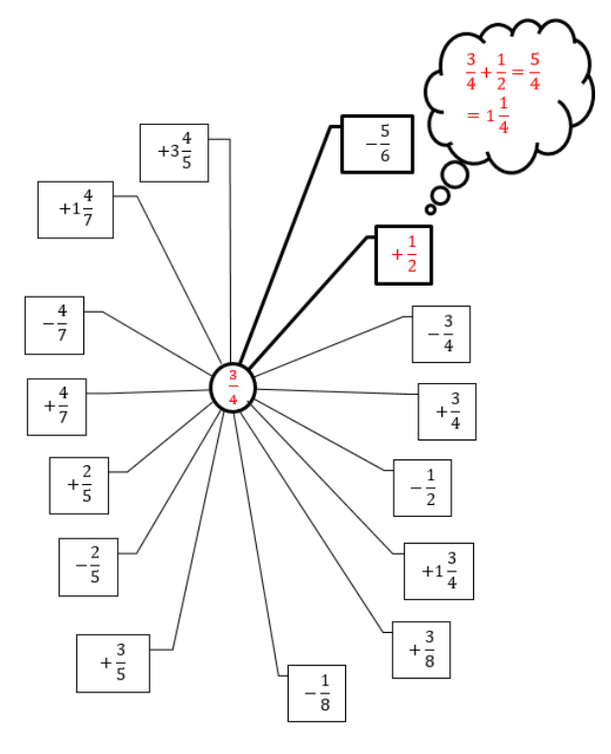

Numeracy and Mathematics – Managing Time
How do you manage your time inside and outside of school? You may already use a diary or planner to plan ahead. You could watch the clip below to give you some tips and ideas on how to get organised.
https://www.bbc.co.uk/bitesize/articles/z83cqhv
If you have a copy of your school timetable, look at this and think of what other activities you would usually participate in during a week. For example, sporting activities, homework, music practice, time for friends, use of social media.
Estimate the length of time you spend on different activities and tasks, and create a planner which shows all of your weekly commitments for the term ahead. You could use your school timetable layout or a digital planning tool.
Looking at your planner, are there any days where you feel that there are too many tasks to complete? What tasks are essential and how can you rearrange your planner to spread these tasks more evenly across the week?
Are there particular subjects that you find challenging? Think of ways to help you overcome some of these challenges. For example, break subject content into smaller pieces, speak to family members about how they study effectively or ask for some advice from your teacher. Build time into your planner to include some of these strategies in your daily routine.
A few weeks into the new term review your planner. You may want to consider the following questions;
- are you managing to follow your plan and is it working for you?
- is your workload manageable?
- is there a balance of time between school work and other activities?
You could speak with family members about possible ways to improve your plan.

Numeracy and Mathematics - Patterns
Can you write down the first five numbers of each number pattern you can think of? For example, the first five; odd numbers, even numbers, square numbers, triangular numbers and prime numbers.
Here is a reminder about working out the next terms in number sequences.
Equipment: ruler and square paper.

Part 1
Draw Shape 4, the next T shape in the pattern below. How many dots are there in this shape?
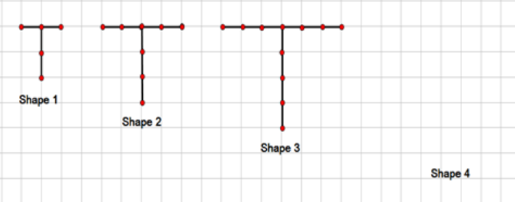

Copy the following table.
Shape number (s) | 1 | 2 | 3 | 4 | 5 | 6 |  | 12
Number of dots (d)

Fill in the number of dots in shape 2 and 4. Can you predict how many dots will be in Shape 5 and 6.

Now write down a rule for the number of dots (d) when you know the shape number (s). Hint: remember to find the difference between the number of dots to start to find your rule (again, the bbc bitesize link above may help here).
Use your rule to find how many dots are in Shape 12. You can check if you are correct by either drawing out Shape 12 or continuing the pattern in the table.

Imagine 107 dots are used to draw a T-shape, use your rule to find the shape number?

Part 2
Look at the sequence of numbers below.

1 1 2 3 5 8 ? ? ?

What are the next three numbers in this sequence and find a rule for determining the next number in the sequence?
See if you can find any other patterns when you look at this sequence of numbers. For example, is every third number divisible by 2? What about every fourth number in the sequence?

This is called the Fibonacci sequence of numbers. This sequence appears in real-life and plays a very important role in mathematics. Investigate the history of Fibonacci numbers and find out where they appear in the real world. Find out more about Fibonacci numbers.

Literacy and English (Writing) – A Short Story About Change

Read the following opening paragraph of a short story about a family dealing with a big change. You will go on to plan and complete the story.
The family sat in the car outside the large, empty house. Mum was talking about how wonderful it will be to live in the big house, the many amenities of the new town and how much more there is to do here compared to the old neighbourhood. However, the family knew mum was as nervous as they were. This was a huge change and one that they all felt both excited and scared about. Would it all work out for them? The younger son let out a silent sigh. He was already missing the friends he’d just said goodbye to and was annoyed at his mum for being so falsely positive. His older sister slapped his arm gently and glared at him. It is easy to get annoyed she thought, and much harder to see the opportunities in the move. She knew that she needed this fresh start and secretly wondered if her mum had organised the move for her benefit. Each of them sat in the car, looking at the house, and knew it was down to them to make it work.
Before you start to write the story, use your imagination and plan what is going to happen. Think about why the family are moving and what will happen next. Try to develop each character and think about their relationships with each other. How is each character going to respond to the change, and what strategies could they use to make the transition successful? Consider where the short story is going to take place, and how you are going to develop the theme of change throughout.
To make your short story most effective, make sure you use descriptive language, dialogue, developed characters and a powerful ending. Please also ensure you check your writing and fix any spelling or grammar errors. The following advice on writing a good short story may be useful.
Share your work with a member of your household and ask them for feedback on your writing. Ask if they found your characters and situation believable. Ask if they felt you dealt with the theme of change well. Are there any improvements you could make?

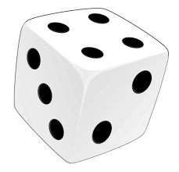
Self-reflection Grid
At the end of a day of learning you might like to roll a die to select a self-reflection question. You can look at them by yourself or, even better, discuss them with someone else.

1 | 2 | 3 | 4 | 5 | 6
Did I find it easy to stay on task? What helped/ hindered this? | Am I worried about anything after today’s work? What can do if I am worried? | Did I get stuck? How did I get past that? Did I give up or try something else? What did I try? | What made my learning stick today? What did I do that helped me understand a particular task? | Did I have everything I needed to complete the tasks? Did I use anything to help me? | Were there any tasks today that I found too easy? Why? Could I have added my own challenge?

