Tuesday 9th June We hope this finds you all well and that you will find these suggestions helpful. Please feel free to adapt or extend ​them as you see fit.
Literacy
Learning intentions: I am learning improve a piece of writing by adding details. I am learning how to help the reader visualise the story by giving them lots of clues. ​Success criteria: *I can improve the story by describing the setting. *Add in a smell. *Add in a sound. *Add in a feeling. *Add in what you can see. *Add in a taste.

Improve the story- We can improve a basic story by adding descriptions about what you can see, hear, smell, taste and feel. You can watch Mrs Bowes improving her story and then you can have a turn. Talk it through with a partner first. then you could write out your better version of the story.

Mrs Bowes clip: https://vimeo.com/427180099/5cd0b44720

Then you can have a turn of your own with the story below.
​
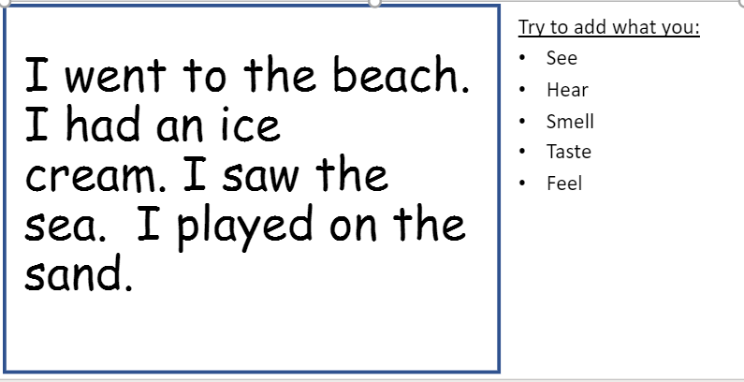
​
Grammar- Log on to Sumdog and select Grammar training (Recommended 10 mins). See how many coins you can for playing the games. We can't wait to see how you are getting on. ​
​
Compound Matching Game – Can you find the match to create a new word? Use a word from each column on the next slide to create a compound word. This can be a talking task or you could write the words you create on a bit of paper/ whiteboard to avoid printing. ​
​

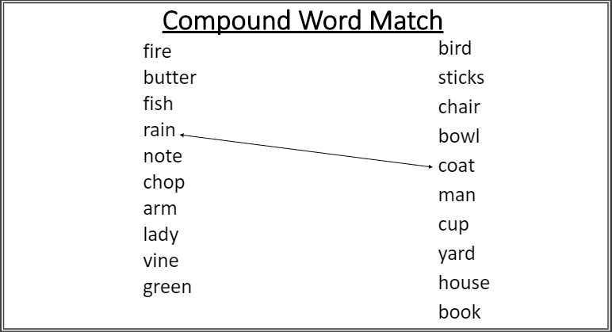
Key words to read and write

Tricky word- don’t
Spelling rule- Compound words with two syllables/ beats.
Adult's words to model spelling- notebook, playhouse, armchair
Children's words to try spelling- railway, eyelash, skylight
Key Sentences- Can you read these sentences to an adult? We have underlined the compound words to help you
Paul did a cartwheel round the room and fell in a heap on the ground.
The mice don’t like to come out in the daylight and be seen.
Keep off the edge of the bank and get back into the houseboat before you fall into the water.

Maths

Learning intentions: ​I am revisiting the months of the year. I can apply my maths knowledge to answering the question in the teams quiz. Success criteria: *recall the months of the year in the correct order *complete the maths quiz
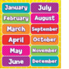
Warm up - Months of the year practise – Watch this video to revise the order of the months of the year​: https://www.youtube.com/watch?v=Fe9bnYRzFvk
After you have watched the video you could ask someone to ​ask you questions about the order of the months of year e.g. what month comes after March? What month comes​
Before July? If you are quick to answer these they could ask you what is 2 months after August? Or 2 months ​before? ​
​

Follow up: A short message from the P2 team- https://vimeo.com/427180099/5cd0b44720

Activity –Teams task:
Try to complete the P2 maths quiz we have uploaded on Teams​ today. It will appear at 9 o’clock in the morning. You can click to hear the questions being read aloud, and you can ask an adult to help you fill in your answers. ​Don't worry about getting questions wrong as this tell the P2 team which areas in maths we need to revisit in the ​weeks to come. ​

Across the curriculum
Learning intentions: I am learning about the artist Mondrian. I can make my own art inspired by a famous artist. Success criteria: * Use a ruler to draw vertical and horizontal lines. * Colour in some of the squares using bold colours.

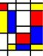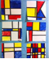
Art – Mondrian is a famous artist. ​
https://www.youtube.com/watch?v=xkq5jQhH0WE
(tour of some of his work in the Tate Gallery in London)​

Follow up task- Try to make your own picture inspired by the artist. First use a ruler and black pen or pencil to draw straight lines going down and across the page. Choose some bright colours to colour in some of the rectangles and squares. Remember to leave some white. We would love to see some of them on our P2 show and tell channel.

