Thursday 11th June- We hope this finds you all well and that you will find these suggestions helpful. Please feel free to adapt ​or extend them as you see fit. ​
Literacy
Learning intensions: ​I am learning to write a review. I can use a word bank. I can spell some compound words.
Success criteria: *Capital letters and full stops. * Finger spaces. *Add in the location. ​*Use 'and' or 'because’.​ *Add in a feeling. *Add in some doing words.

Writing - Review of our Virtual Sports Day
​
Yesterday you might have taken part in our Virtual Sports Day by trying out one of the activities from the grid. Can you think back on the different actions you did? Did you jump? Run? Hop? These types of words are called verbs, which are doing words. Can you write a review of your experience of sports day or a similar sporting event to upload in teams?​

You could include your favourite activity, why was it your favourite? How you felt? Where did you do the activity ​(living room, garden etc.)? You could also include a picture of yourself taking part. ​
Mild – Write 3 sentences Hot – Write 4 sentences Spicy – Write 5 or more sentences​

Remember to include capital letters, full stops and an illustration. ​
​
Here is a help sheet/word bank which you may find helpful (no need for printing).​

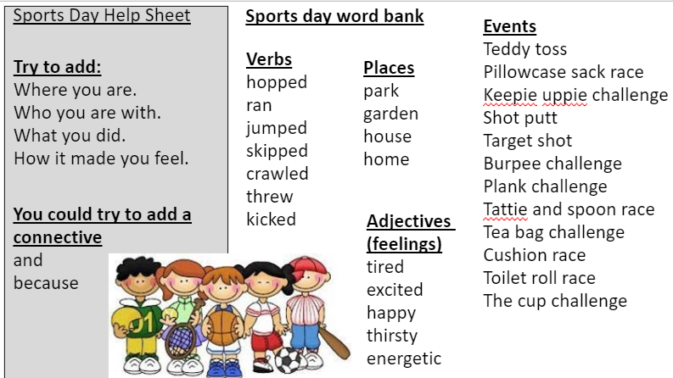
​

Key words to read and write
Tricky word- both don’t won’t
Spelling rule-Compound words with two syllables/ beats.
Adult's words to model spelling-toolbox, football, corkscrew
Children's words to try spelling- lipstick, armchair, starfish
Key Sentences- Can you read these sentences to an adult? We have underlined the compound words to help you.
Paul did a cartwheel round the room and fell in a heap on the ground.
The mice don’t like to come out in the daylight and be seen.
Keep off the edge of the bank and get back into the houseboat before you fall into the water.
Maths
Learning intentions: I am learning to counting within 100. I am learning to use a calculator. Success criteria: * Know number before and after. *Use calculator correctly to solve sums.

Warm up song counting to 100: https://www.youtube.com/watch?v=bGetqbqDVaA​

Number jumps - Here is short clip to help you see how to use the game below: https://vimeo.com/427651466/2e04683a5d​
Game- Open the digital Number Line (https://apps.mathlearningcenter.org/number-line/). ​
Instructions: Click the "Line Settings" button and choose your spacing (narrower space is more challenging). Click on the "Line Masking" button, which will hide all numbers. Reveal ONE number by clicking on the blue square. Work out which ​
number you get to if you move e.g. 4 jumps up/ forward or 5 jumps down / back on the number line. ​
Medium- numbers in the 1-30 range, Hot- numbers in the 1-50 range, Spicy 1-100 range. ​
Note: If you hover over the different buttons, you'll be able to see their names. You only need the "Line Settings" , ​"Line Masking" and the pencil buttons. ​

Task: Use your counting skills to complete Heinemann workbook 3, pages 3 and 4 or try the problems on the sheet below. ​

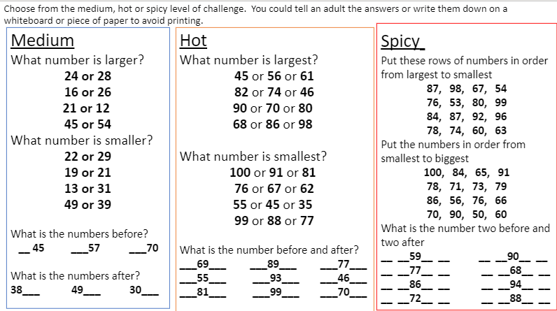

Across the curriculum

Learning intentions: I am ​learning more about the Rainforest and some of the animals that live there. Success criteria: *Watch clips.​ *Complete the bitesize quiz. * Talk about the animals in the clip.

Topic- Find out more about the Rainforest ​
Follow this link to find out more about the Amazon Rainforest from BBC bitesize:​
https://www.bbc.co.uk/bitesize/topics/zx882hv/articles/zxdsvcw​

Relax while you watch these Rainforest images (2 mins). Do you recognise any of the ​animals? Tell a partner which one you would like to find out more about. We will be ​learning more about some of them next week.​ https://www.youtube.com/watch?v=5IzzogrKo6k​

