Monday 15th June- We hope this finds you all well and that you will find these suggestions helpful. Please feel free to adapt or extend them as you see fit.
Literacy
Learning intentions: I am ​learning to read unfamiliar words in a non-fiction book. I can read and spell compound words. I can explain what compound word are.​ Success criteria: * Read and spell compound words correctly. *Write my first name and surname correctly. *Read unfamiliar words in ​the e-book.

Handwriting- It is good practise for going into P3 to be able to write you first name ​and surname on your work. See if you can practise writing your full name using cursive letters. ​You could try using chalk on the ground, water brushed on the ground outside, rainbow letters ​with coloured pens etc. ​
Reading – Choose one of the e-books to find out more about the Rainforest animals. Remember, ​there is a read out loud option if you get stuck on any of the words. ​
Med/Hot 'Poison Dart Frog' e-book:
https://readon.myon.co.uk/reader/index.html?a=cwa_pdfro_f11​
Hot level 'Sloth' e-book:
https://readon.myon.co.uk/reader/index.html?a=saa_sloth_f12​
Hot level- 'Howler Monkey' e-book:
https://readon.myon.co.uk/reader/index.html?a=saa_homon_s12​
Spicy level- 'Who grows up in the Rainforest': https://readon.myon.co.uk/reader/index.html?a=gro_rainf_f02​
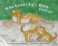
Key words to read and write​
Tricky word- those
Spelling rule-Compound words with two syllables/ beats.
Adult's words to model spelling- raincoat, sunset, nightdress
Children's words to try spelling- downstairs, earplug, rainbow
Key Sentences- Can you read these sentences to an adult? We have underlined the compound words to help you.
Bruce will paint his bedroom walls and his friend Vince will help him.
The maid did the housework and then made herself a pot of tea.
Why don’t we go into the greenhouse and plant some seeds?
Maths
Learning intentions: I am learning to count within 100. I am learning to find missing numbers. I can write numbers correctly. Success criteria: ​* Count correctly to 100.​* Know what number comes 2 or 3 more or less on a number line.

Warm up counting to 100 song: https://www.youtube.com/watch?v=e0dJWfQHF8Y​
​ 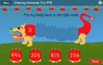
Warm up game (Recommended 5/10 mins)- Can you use your number knowledge to play this ​ordering and sequence game. You can make the game more challenging by changing the types of ​questions or selecting a higher range of numbers. ​
https://www.topmarks.co.uk/ordering-and-sequencing/chinese-dragon-ordering​
​
Follow up activity: Try to complete pages 5 and 6 in your Heinemann 3 workbook or try the medium, hot or spicy questions below. You could tell an adult the answers or note it on some paper so there is no need for printing. ​
​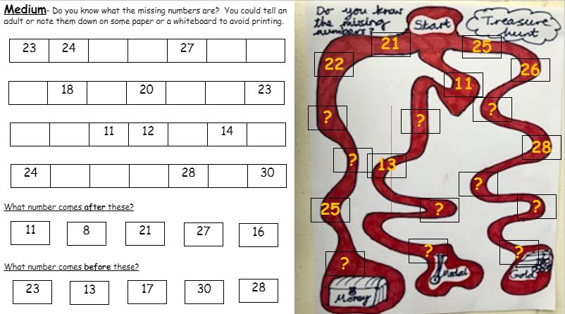

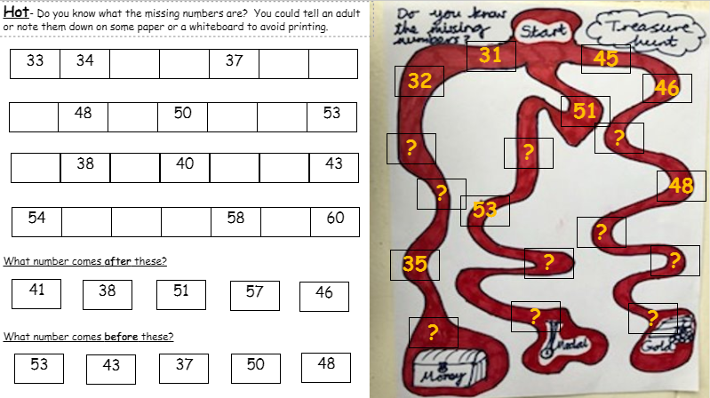

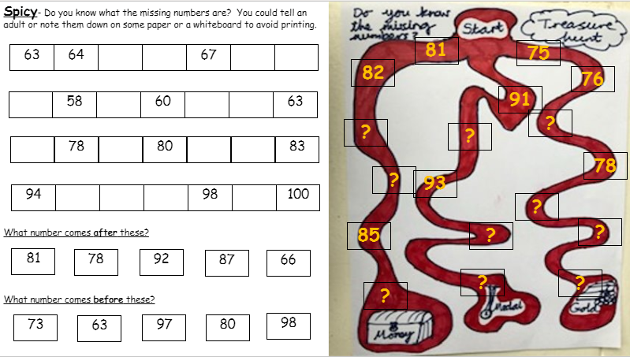

Across the curriculum
Learning intention: I am learning to move my body in different ways. I am improving my balance. Success criteria: *Listen to instructions. ​*Copy the yoga poses. * Hold the balances. ​

P.E with Cosmic yoga ​
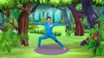
Why not join Stezzi the parrot on a cosmic yoga adventure today. See if you can copy the poses ​and hold the balances.
https://www.youtube.com/watch?v=LIBz0IdOFiQ​

