Friday 19th June- We hope you will find these suggestions helpful. Please feel free to adapt or extend them as you see fit. ​
Literacy
Learning intentions: I can choose books. I can listen and talk about a story. Success criteria: *Talk about the book.​ * Spell key words correctly. ​

Reading – Use your class log in to pick a book for enjoyment​
ttps://www.oxfordowl.co.uk/please-log-in?open_loginbox=true​
Class log in details​
P1/2 My class name: brufp12​
Password: biff​
P2A My class name:brufp2a​
Password: biff​
P2B My class name:brufp2b​
Password: biff​

Listening - Even though a fiction story is made up it can help us understand ​the world around us. Today we would like you to listen to the story of the ​'Little Tree' by Loren Long. Answering questions helps us understand the ​story we have read and think about how it links to our own lives. ​
https://www.youtubekids.com/watch?v=CGquWvJH39M&hl=en-GB ​
Note: If you are new to youtubekids it will ask you if you want to set ​up an account. You can either choose to do this for your child or when it ​asks you to enter your email address you can click 'skip' button below. ​

Choose one of the sets of questions below to answer about the story. ​
Medium: Which animals come to visit Little Tree? How do you think Little Tree felt at the end of the story? Have you ever been afraid to do something?
Hot: What is Little Tree afraid to do? Why does the fox think Little Tree is ill? Can you remember a time something changed in your life and how you felt?
Spicy: How is Little Tree different from the other trees? Why do you think Little Tree didn’t want to let go of his leaves? Have you ever been afraid to say goodbye to something?​

Spelling –Ask the adults to read one of the spelling lists or the sentence out loud. See if you can spell them correctly. ​

Revision​​ | Medium​​ | Hot/Spicy​​
mask​ | sunset ​ | Lift the soap out of the bath tub and place it in the tray. ​
desk​ | rainbow​
tusk​ | teacup​
bark​ | chopstick​
park​ | footprint​
shark​ | bathroom​

Maths

Learning intentions: I am learning to count in 10s. I am learning to add with money. I can complete some Sumdog maths training. ​Success criteria: *count forwards and backwards in 10s. * Complete Sumdog training. * Complete workbook pages or slide. ​
Warm up song (counting in 10s) https://www.youtubekids.com/watch?v=7stosHbZZZg&hl=en-GB ​
​
Sumdog Training - Log on to Sumdog and spend some time answering the training questions​
(recommended 10 mins+). ​
​
​
Task: Try to complete pages 11 and 12 in your Heinemann 3 workbook and/ or try the medium, hot or spicy ​questions on the box below. You could tell an adult the answers or note them on some paper so there is no need for printing. ​
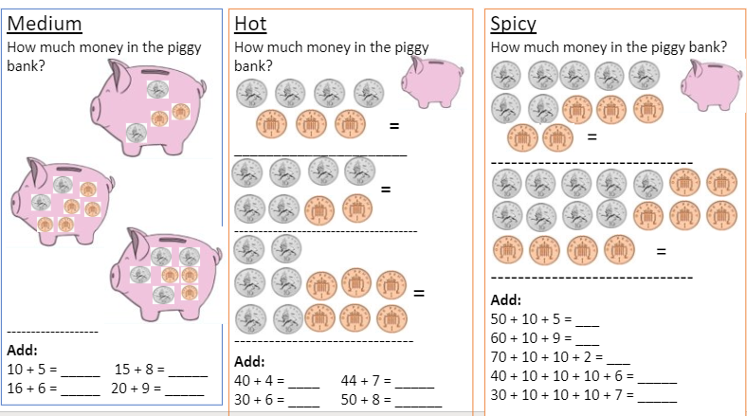
Across the curriculum
Learning intentions: I am learning about food chains. ​I am learning about producers and consumers.​ Success criteria: *I can find the correct order of the food chain. *I can identify producers and consumers in a food chain. ​

Topic Food chains​
https://toybox.tools.bbc.co.uk/activities/id/g6klkqfxx1/exitGameUrl/https%3A%2F%2Fwww.bbc.co.uk%2Fbitesize%2Ftopics%2Fzbnnb9q%2Farticles%2Fzsphrwx/palette/colour-palette-7/language/en-GB/project/blocks-bitesize​
Task- Find the pictures that are part of a food chain in the game. Then select if they are producers or ​consumers and put the food chain in the correct order.

